Instructions for Parent Account Set-up
- Download the CurbSmart Parent mobile app, or in your phone browser, go to login.curbsmart.net and click on CREATE AN ACCOUNT.
- Enter your First Name, Last Name, Email, Username (It will populate your email address as your username automatically) and Password (your password must be at least 8 characters and contain 1 upper case letter, 1 lower case letter and 1 number). You may also enter your Relation to your student and Contact Number, if desired.
- Next, enter the School Code (####) and Placard Number (both are provided by the school) (Figure 1). Click Create Account.
- Next, you will see a prompt to verify the birthdates of each student on your account (Figure 2). Use the drop-down to set the birthdate for each student. Once complete, click Verify. If the birthdates match the school’s database, the account will be created.
  - Note: You may see the message “Someone has already registered for a CurbSmart account using this placard number. You can send a request to join their account below. Please contact your school with any questions or if you need assistance.” This means that someone else (i.e. another parent/guardian) has already registered for a CurbSmart account with this placard number. You can press the button to “Send Request to Join Account.” This will send an email to the account holder to review your request. Once approved, you will receive an email and can proceed with logging in with your username and password.
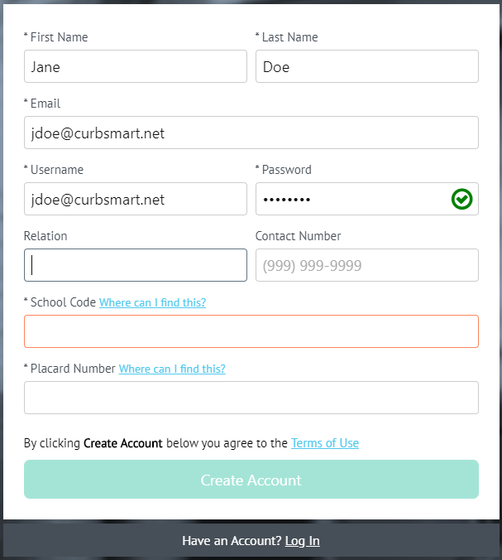

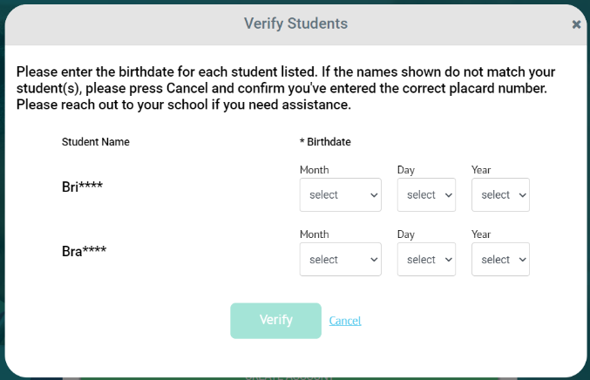

Figure 1 Figure 2
- Login to your account using the username and password you created.
CurbSmart is available through your computer or phone browser (such as Google Chrome or Safari). You can also download the CurbSmart Parent mobile app through the App Store or Google Play Store.
Apple: Google Play:
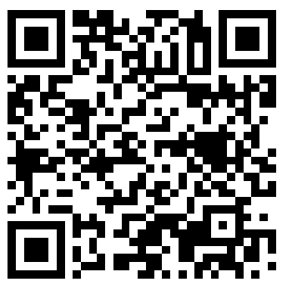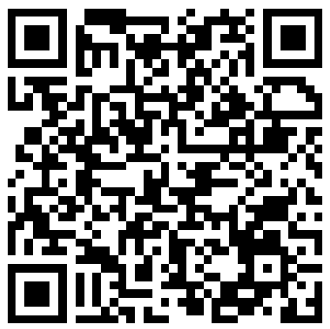
For questions on registering your account, adding adults or students, or making other changes, please visit the CurbSmart Support site at https://nutrilinktechnologies.com/support/curbsmart-help-parents/ or contact [INSERT NAME] at [SCHOOL NAME] at [CONTACT NUMBER] or via email at [EMAIL ADDRESS].

