(School Name) is excited to now offer online pre-ordering of meals at [MyMealOrder.com](http://mymealorder.com). MyMealOrder is a simple and effective way to pre-order and pay for your school lunches online.

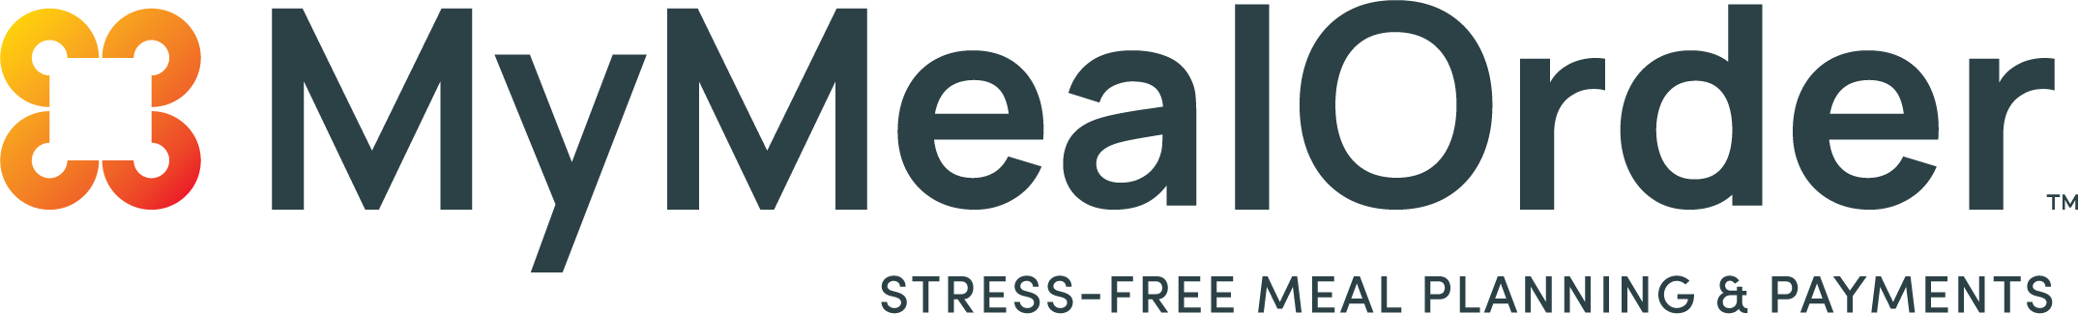

MyMealOrder provides:

* Convenience - Available 24/7 on the web or on any mobile device.
* Efficiency - Make payments for all your children with one account.
* Control – Select the meals and items you want your children to eat.
* Flexibility - Make payments using credit/debit cards and electronic checks.
* Security – MyMealOrder adheres to the highest security standards, including PCI and provides the highest level of security available against card-present data fraud.

Creating an account is simple!

1.     Go to [www.MyMealOrder.com](http://www.MyMealOrder.com) and register for a free account.

2.     Add your students using their student ID, last name and school.

3.     Select your meals in a week view or a month view and complete the checkout process with your credit/debit card or electronic check.

A convenience fee may apply.  You will have the opportunity to review any fees and cancel if you choose, before you are charged.

We are very excited to offer this service and are confident this system will benefit you during your student’s time at (School Name).

MyMealOrder is powered by

